**SLF4J_Logging_Exercises**

## **✅ Exercise 1: Logging Error and Warning Levels using SLF4J**

### **Step 1: Add SLF4J & Logback Dependencies**

Add this inside the <dependencies> section of your pom.xml:

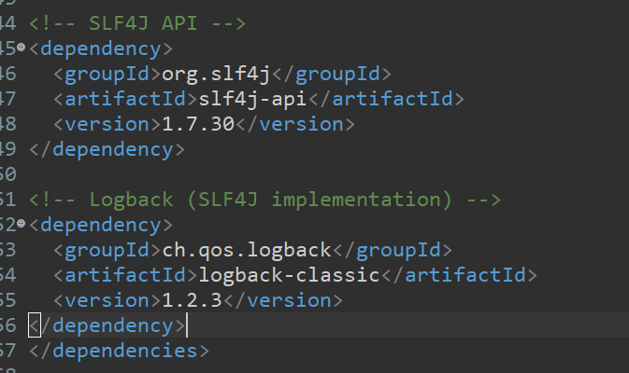

**Step 2: Create Java Class for Logging**

📁 src/main/java/com/example/LoggingExample.java

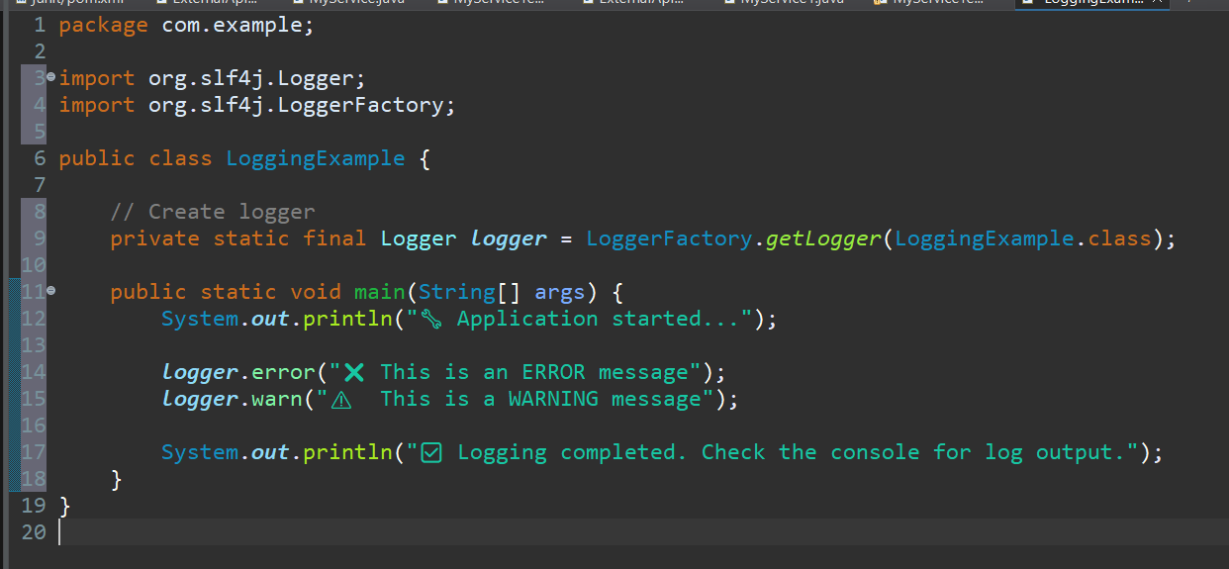

### **Step 3: Run the Application**

Run this file using:

✅ Eclipse: Right-click LoggingExample.java → Run

### **Expected Console Output**

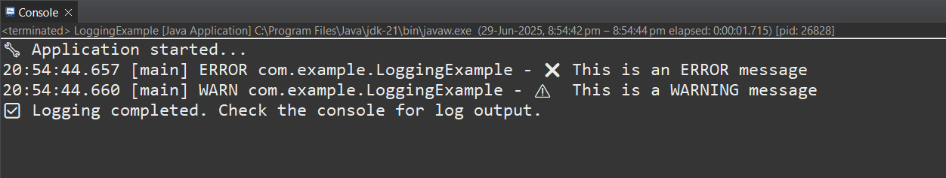 -Mohammed Ayaan